**Project Plan**

***Fit buddy***

Individual project semester 3

|  |
| --- |
| **Date : 22.02.2023** |
| **Version : 1.0** |
| **Author : Stoyan Grozdev** |

#### Version history

|  |  |  |  |
| --- | --- | --- | --- |
| **Version** | **Date** | **Author(s)** | **Changes** |
| 1.0 | 22.02.2023 | Stoyan Grozdev | Creating the project plan |
|  |  |  |  |
|  |  |  |  |

Contents

1. Project assignment 3

1.1 Goal of the project 3

1.2 Scope and preconditions 3

1.3 Strategy 3

1.4 End products 4

2. Project organisation 5

2.1 Communication 5

3. Activities and time plan 6

3.1 Phases of the project 6

3.2 Time plan and milestones 7

4. Testing strategy and configuration management 8

4.1 Testing strategy 8

4.2 Test environment and required resources 8

4.3 Configuration management 8

5. Finances and risk 9

5.1 Risk and mitigation 9

# Project assignment

## Goal of the project

The project aims at developing a web application for gym members. The

software system is going to serve as a meeting point for people who want to start a new active lifestyle and also for those who already go to the gym. The goal of the

project is to provide pre-set workout plans for bodybuilding the needed functionalities for the people who want to keep track of their progress and see statistics of their fitness journey, also with a premium subscription you get access to a personal trainer who can help you with building the perfect exercise routine for you and also give you general advice with dieting and answer all of your fitness related questions. To ensure quality and accuracy of the information in the website, the system will support an account for an administration who can add, change, remove exercises and also see detailed statistics about the used equipment in the gym.

## Scope and preconditions

|  |  |
| --- | --- |
| **Inside scope:** | **Outside scope:** |
| 1. The fitness web application will allow users to select workout plans or create their own and track their progress. | 1. The application will not include nutrition tracking or meal planning features. |
| 1. The application will include a library of exercises with videos or photos on how to do them. | 1. The application will not include personalized workout plan recommendations based on user data or fitness goals. |
| 1. Users will be able to customize their workout plans and save them for future use. | 1. The application will not allow for multiple gym support. |
| 1. The application will include social features that allow users with premium subscription to chat with a personal trainer. |  |
| 1. The application will allow the user to see statistics of their progress. |  |

Preconditions:

The fitness web application will be developed using React as the front-end framework and Java as the back-end technology.

Spring Boot will be used as a framework

Lombok will be used as a library

Gradle will be used as automation tool

The application will use a MySQL database to store user data and workout information.

An ORM (Object-Relational Mapping) will be used in order to simplify the process of communicating with the database.

## Strategy

Agile methodology will be used for this project because it is flexible, adaptable and has short sprints, emphasizes on long-term process as it always can be changed while waterfall methodology requires clear and detailed plan upfront, has longer development cycle which can delay product delivery, is less conductive to continuous improvement since each phase must be completed before moving on to the next one. Additionally the scrum-based project is ideal for this kind of project.

The project management tool chosen for this project is Jira, primarily because of its compatibility with Scrum methodology. Jira offers many benefits that can enhance the flexibility and efficiency of a Scrum project. Jira's agile features allow for easy modification of project requirements and tasks as the project progresses. This flexibility is essential when using Scrum, as it enables adjustments to the scope of the project and re-prioritization of tasks based on changing requirements. Jira's customizable workflows can split work into smaller tasks and rank them based on their level of priority. This functionality ensures that the most crucial functionalities for the product are implemented first and clarifies what needs to be delivered after every sprint. Jira's collaborative workspace promotes interaction and enables quick feedback on completed tasks. This ensures that all team members are aligned and focused on accomplishing common goals, which is especially helpful during Scrum sprints. After every sprint, meetings can be gold to discuss the sprint’s progress, identify areas for improvement, and prioritize tasks for the next sprint. Finally, Jira could be very useful when it comes to

testing and ensuring the product quality because it allows constantly testing of

small parts rather than everything at the end.

## End products

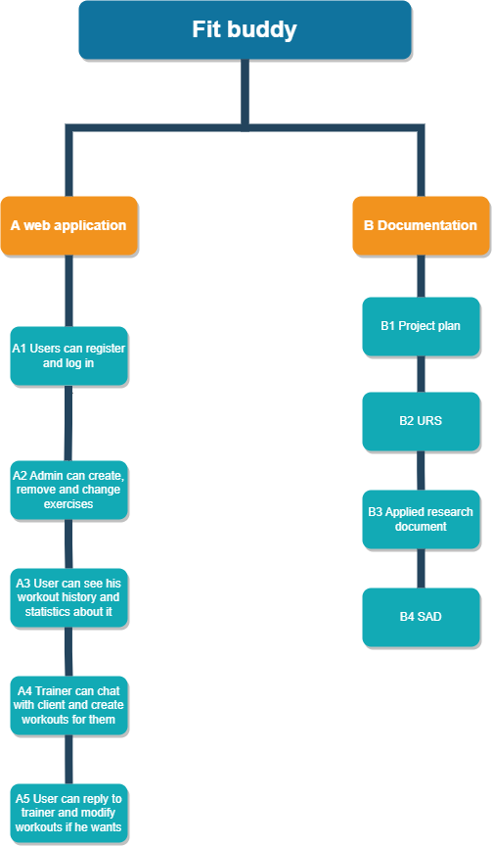

# Project organisation

## Communication

A feedback session with one of the technical teachers is organized following each sprint in order to go through the sprint's deliverables and get feedback on them. Moreover, there will be

meetings with the technical instructors to assess the students' current development and provide assistance as necessary.

# Activities and time plan

## Phases of the project

The project will be split in different sprints. Each sprint will be ranging between 3-4 weeks duration. That leaves us with 6 sprints. Each spring will have deliverables which will be discussed prior submission and after submission with the lectors. Each sprint will consist of different components, as shown in the table below:

|  |  |  |  |
| --- | --- | --- | --- |
| **Sprint** | **Phase** | **Activities** | **Deliverables** |
| 1st Sprint | Initiation | This phase will consist of mainly  creating a project plan, choosing managing tool, creating user stories and creating the first setup of RESTful API services for the backend. | Project plan, backlog, project backend(basic requests and responses on a blank page) |
| 2nd Sprint | Implement | This phase will be dedicated to explaining the architecture constrains and backing up our design decisions, making the C4 Model diagram, configuring CORS for the controllers, configuring the frontend and making the applied research document | Design document version 1, additions to the backend, frontend setup, applied research document |
| 3rd Sprint | Implement | This phase will be dedicated to creating the UML class diagram, setting up the database and rounding up the research document | UML class diagram, database set up, SonarQube installed and running plus its implementation, research documents addition |
| 4th Sprint | Implement | In this phase the CI diagram will be made, the login functionality of the website will be made plus its additional requirements(JWT based, etc.…), unit test will be created. | CI diagram, unit test, additional additions to documentation |
| 5th Sprint | Implement | This phase will finish the documentation, security report will be made detailing how the application deals with security risks, a chat function will be added to the application to cover the WebSocket feature and a bug review will be done | Security report, chat function for trainers |
| 6th Sprint | End Phase | In the final phase a UX feedback report will be done, final project version will be made and a rehearsal of previous learned material will be made. | Final application and documentation |
|  |  |  |  |

## Time plan and milestones

|  |  |  |  |
| --- | --- | --- | --- |
| **Phasing** | **Effort** | **Start date** | **Finish date** |
| 1. Sprint 1(Phase 1) | 144 hours | 04/02/2023 | 03/03/2023 |
| 1. Sprint 2 (Phase 1) | 114 hours | 03/03/2023 | 24/03/2023 |
| 1. Spring 3(Phase 1) | 114 hours | 24/03/2023 | 14/04/2023 |
| 1. Spring 4 (Phase 2) | 160 hours | 14/04/2023 | 12/05/2023 |
| 1. Spring 5(Phase 2) | 106 hours | 12/05/2023 | 02/06/2023 |
| 1. Spring 6(Phase 3) | 114 hours | 02/06/2023 | 23/06/2023 |
|  |  |  |  |

Reference: Working week is 38 hours

# Testing strategy and configuration management

## 

## Testing strategy

Why:

As it confirms that the capabilities are working as intended, testing is essential to the software development process because it raises the possibility of providing the client with a high-quality finished product. Early defect or unusual behaviour detection allows developers to address and fix problems prior to software deployment, potentially saving time and money.

What:

CRUD functionalities for exercises

Requests functionalities

Logging and registration

CRUD functionalities for users

How:

1.Unit tests:

-On Business layer

-On Controller layer

-On Persistence layer

2.Integration tests

3.Acceptance test

## Configuration management

The product backlog will be stored in jira. Gitlab will be used. In order to use gitlab effectively, there will be separate branches into which changes will be pushed. Once that the code is verified sound, the branch will then be merged with the master branch.

# Finances and risk

## Risk and mitigation

Risk 1: Falling behind with the deliverables from the sprint

Probability: Low

Impact on the project: High

Steps to prevent:

Regularly check the deadlines assigned to the deliverables and start working on them as soon as possible.

If it happens:

If I am falling behind with the deliverables, I will inform the one of the lectors about the reasons behind it and discuss the upcoming steps which I will take in order to get back on track as soon as possible.

Risk 2: Insufficient Knowledge

Probability: Medium

Impact on the project: Low

Steps to prevent:

In the beginning of the project, I will attempt to identify all potential research areas which will require further knowledge to counter it.

If it happens:

If it happens I will search for help fellow students and friends also if needed I will ask for feedback from my lectors.

Risk 3: Tutors not satisfied with the solution

Probability: Low

Impact on the project: High

Steps to prevent:

During feedback meetings I will attempt to identify and document the given feedback to implement in the project. Organize feedback sessions outside the scheduled ones from the graphic.

If it happens:

Depending on the time when this problem occurs(i.e. in the beginning of the project), discuss with the lectors which parts are eligible to be adjusted.

If this problem is identified halfway through the project the I will dedicate extra working hours to improve the solution.

If this problem is identified towards the end of the project, I will discuss with the lectors which aspects have priority and work on improving as much as possible before the end of the project.